**The Ark Documentation.**

**Add new subject: study-specific demographic data.**

Once you have seen the confirmation message that the new subject has been created, you can proceed to add additional information.

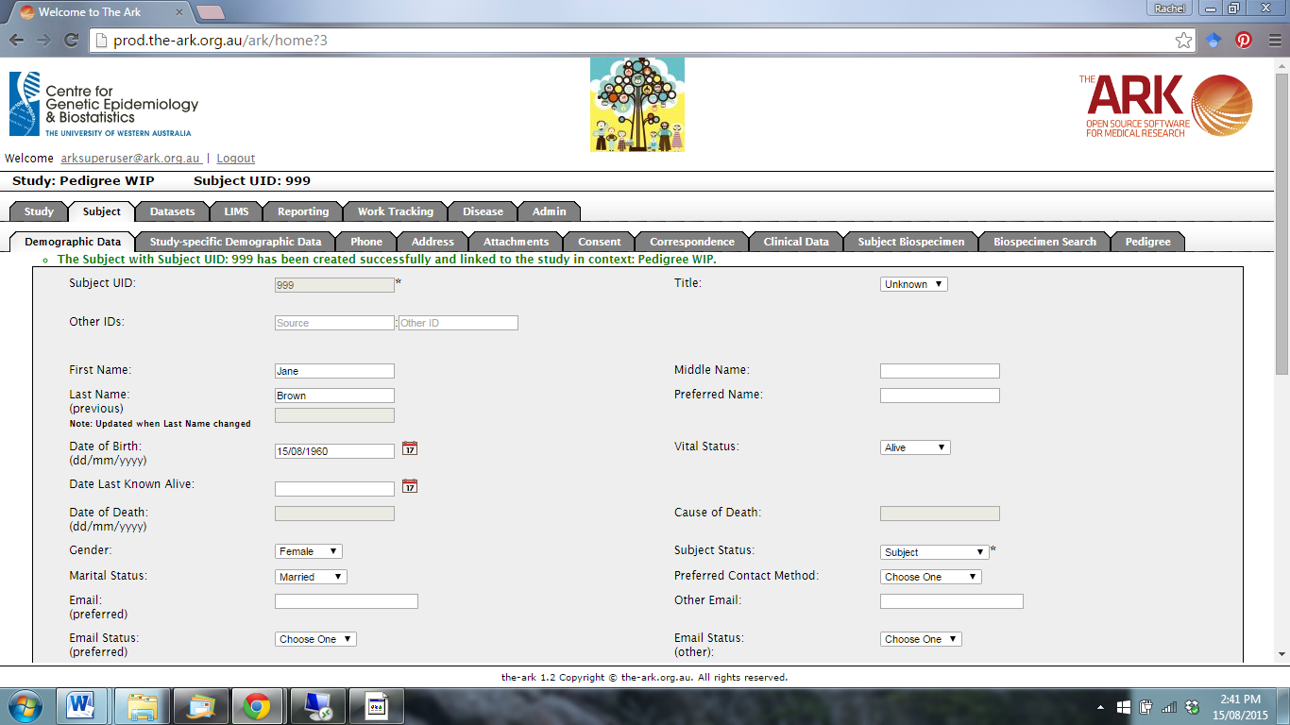

Click on the Study-specific Demographic Data function.

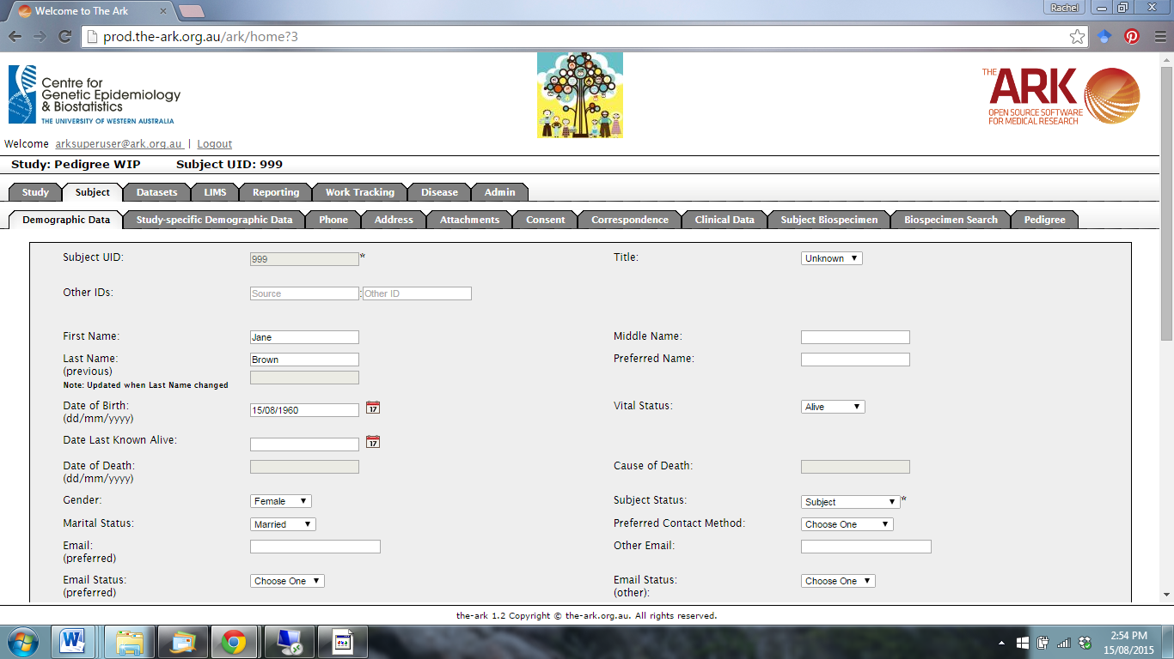

The following page will appear.

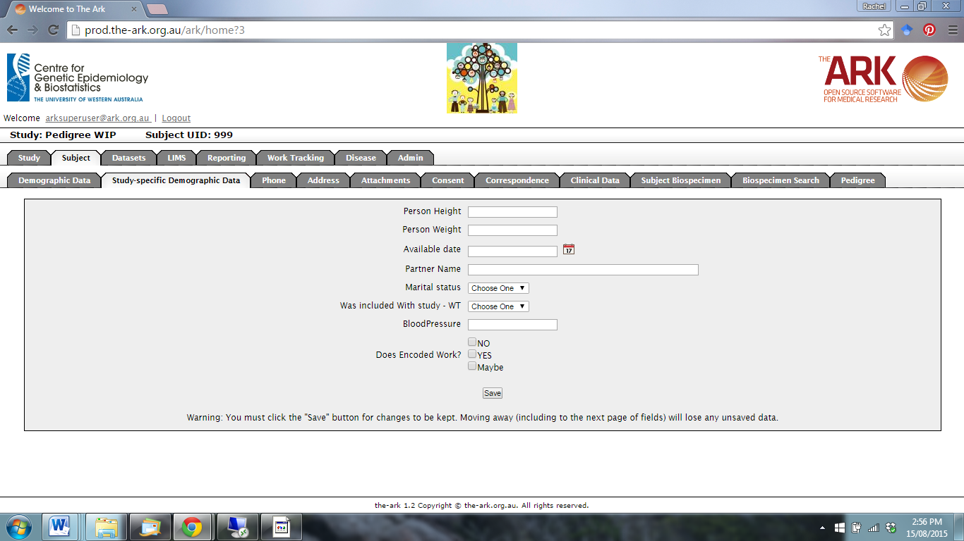

Note: The data fields may appear different for your study.

Enter the information for the new subject, and click save.

